# Unified Modeling Language

Unified Modeling Language (UML) is a standardized modeling language in the field of software engineering. It provides a set of graphical notations to express the design and analysis of software systems. UML diagrams are widely used to visualize, document, and communicate different aspects of a system. Here are some commonly used UML diagrams with examples:

1. Class Diagram:

- Represents the static structure of a system.

- Shows classes, their attributes, methods, and relationships.

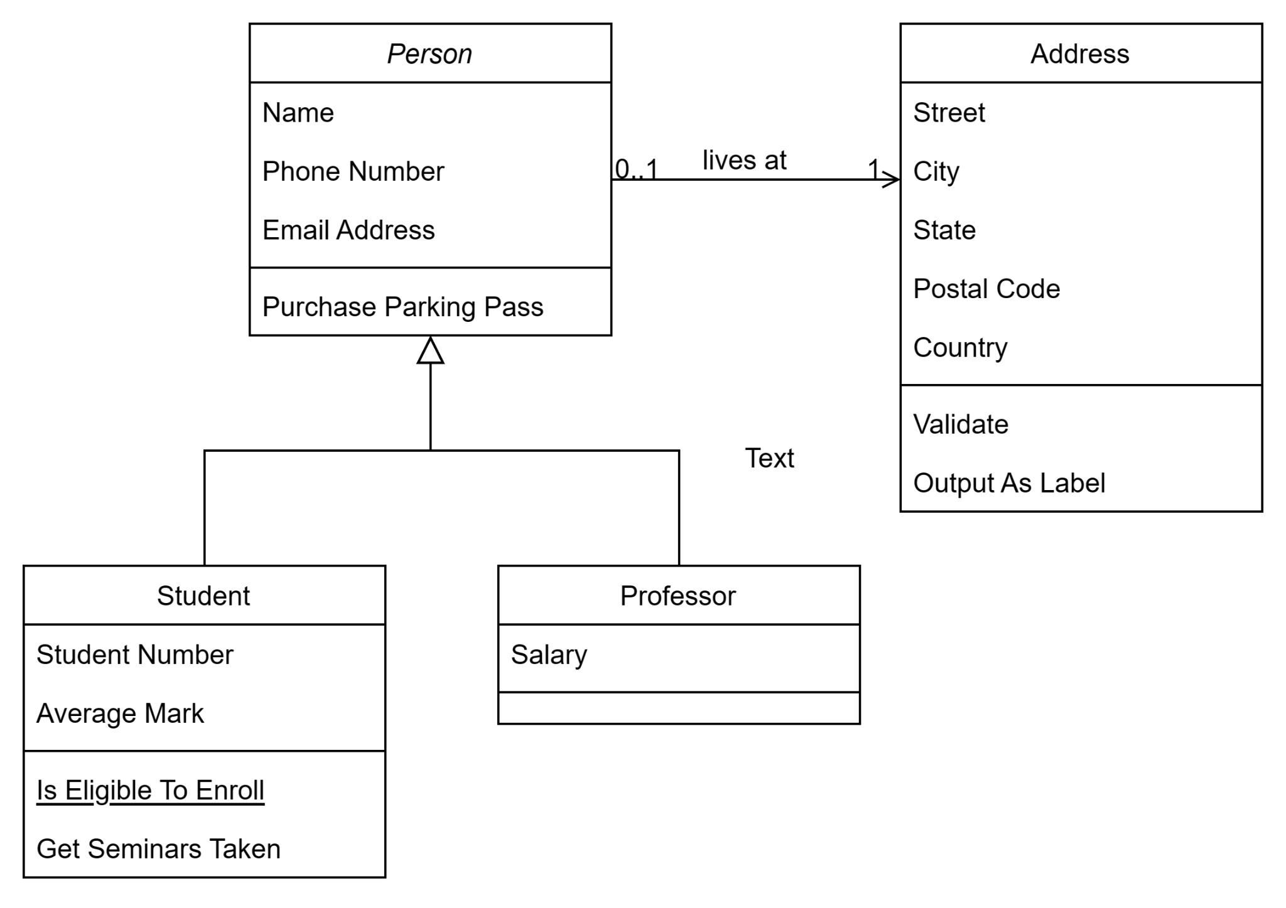

2. Use Case Diagram:

- Describes the functionality of a system from the user's perspective.

- Shows actors, use cases, and their relationships.

3. Sequence Diagram:

- Represents interactions between objects over time.

- Shows the flow of messages between objects.

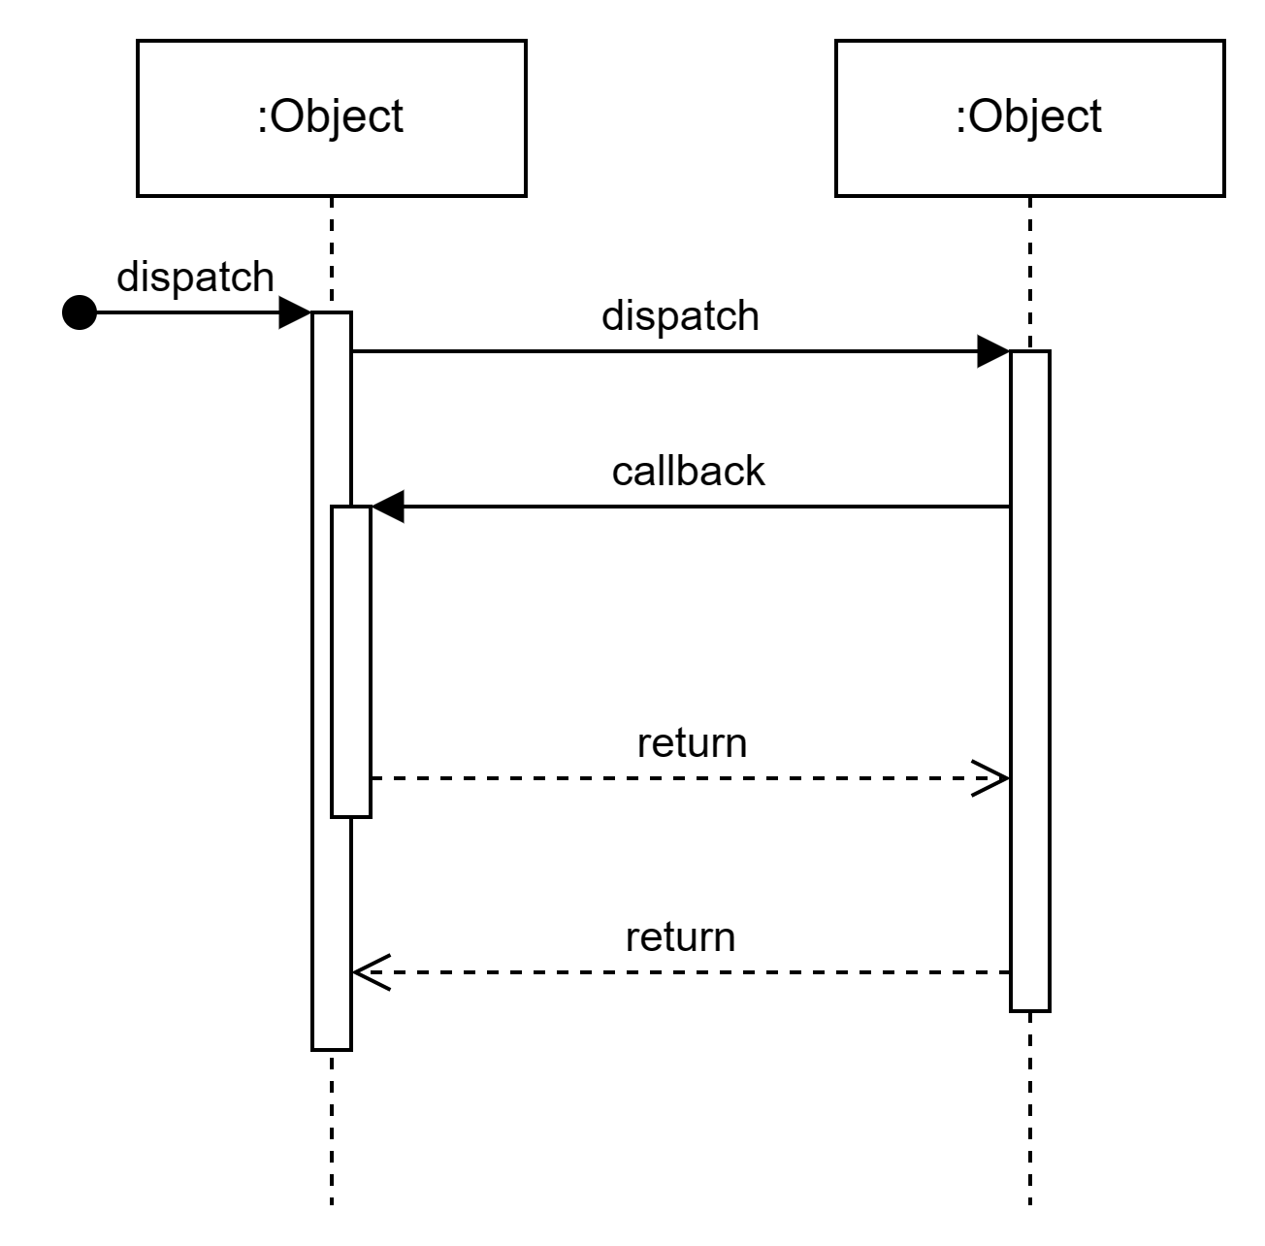

4. Activity Diagram:

- Represents the flow of activities within a system.

- Shows actions, decisions, and control flows.

5. State Diagram:

- Represents the dynamic behavior of an object over time.

- Shows different states and transitions between them.

# Data Flow Diagram (DFD):

A Data Flow Diagram (DFD) is a graphical representation of the flow of data within a system. It shows how data is input, processed, stored, and output within a system. DFDs use various symbols to represent processes, data stores, data flow, and external entities.

Components of a DFD:

1. Processes (Rectangles):** Represent activities or transformations that take place within the system. Each process has inputs and produces outputs.

2. Data Stores (Parallel lines): Represent where data is stored within the system. These can be databases, files, or any other storage mechanism.

3. Data Flow (Arrows): Represent the flow of data between processes, data stores, and external entities. Arrows show the direction of data movement.

4. External Entities (Ovals): Represent external entities, such as users or other systems, that interact with the system but are not part of it.

# 

# Entity-Relationship Diagram (ERD):

# 

An Entity-Relationship Diagram (ERD) is a visual representation of the relationships among entities in a database. It's particularly useful in database design to model the structure of a database and how different entities relate to each other.

Components of an ERD:

1. Entity (Rectangle): Represents a concept or object in the system that can have data stored about it. Entities often correspond to tables in a relational database.

2. Attribute (Oval): Represents a property or characteristic of an entity. For example, a "Person" entity might have attributes like "Name" and "Age."

3. Relationship (Diamond): Represents the association between two or more entities. Relationships are typically labeled to describe the nature of the association.

In this example, there are two entities, "Customer" and "Order," with their respective attributes. The "Purchase" entity represents the relationship between a customer and an order, with attributes specific to the purchase.

Both DFDs and ERDs are valuable tools in system analysis and design, providing a clear and visual way to understand and communicate the structure and flow of information within a system.

Certainly! The concepts of "call by value" and "call by reference" refer to the way parameters are passed to functions or methods in programming languages.

# Call by Value

In "call by value," the actual value of the argument is passed to the function. The parameter inside the function is a copy of the argument, and any modifications to the parameter do not affect the original value outside the function.

Example in a programming language (e.g., C++, Java):

# Call by Reference:

In "call by reference," a reference to the memory location of the argument is passed to the function. Any modifications to the parameter inside the function affect the original value outside the function.